LIFESPAN REPRESENATATIVE BULLETIN NOTES, AUGUST 2026

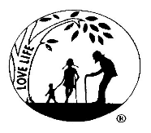
August 1, 2 Right to Life-LIFESPAN Primary Elections.
Voting is not just an opportunity but also a responsibility. LIFESPAN is a 501 c 3 organization and cannot recommend or endorse political candidates. We do ask that you examine the candidates and issues on your ballots and vote for those who most align themselves with your desires for our country.

August 8,9 Right to Life-LIFESPAN Moms.gov
Moms.gov is a new federal web site from the HHS which is designed for expecting and new parents offering information on maternal health and federal family support programs, including health center locations, financial and medical programs, maternal programs, and other resources for pregnant and parenting families.

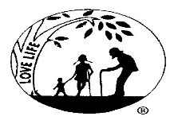
August 15, 16 Right to Life-LIFESPAN LAI
What is LAI? Over the course of three days, participants, ages 16-25, learn to effectively respond to pro-choice arguments and engage in meaningful conversations. The program includes hands-on outreach activities in key Michigan cities. This year Lifespan’s generous donors have allowed us to sponsor 19 students for this experience. We are grateful to all those who made it possible to offer this to our young people. For more information, please call the LIFESPAN office, 248-816-1546.

August 22,23 Right to Life-LIFESPAN Do We Succeed?
“You can’t go back and change the beginning, but you can start where you are and change the ending”.

August 29, 30 Right to Life-LIFESPAN National Day of Remembrance
Please join us at White Chapel Cemetery on September 12, at 1:00 as LIFESPAN observes the National Day of Remembrance of the Aborted Child with a brief ceremony and the laying of red roses on the memorial of babies John, Anthony, Joseph, Mary and Grace. For more information, please call the office, 248-816-1546.

Please join us for a short memorial service with a rose ceremony at the grave of our precious children

Please join us for a short memorial service

Please join us for a short memorial service with a rose ceremony at the grave of our precious ceremony at the grave of our precious children

