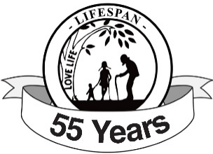
WAYNE COUNTY CHAPTER NEWS
June 2026
Hello Pro-Life Heroes
We did not hear back from anyone in May (admittedly an extremely busy month for many of us), so we will repeat these important questions in June: Are you using LIFESPAN Church Notes in your church bulletin or organization newsletter? Would your community or organization benefit from a presentation on the looming threat of assisted suicide? Do you have a church festival this summer or fall for us to assist with a pro-life booth or materials? Do you have a new pastor, principal, youth minister, Christian Service coordinator, church secretary, or bulletin editor to inform us about? Please call or email Tim or Andy and let us know at (734) 422-6230, wcdr@rtl-lifespan.org, or tpruse@milifespan.org.
6th Annual Links for Life Golf Outing
The newest flier with an updated QR code is in these notes. This updated QR code allows anyone to register and pay via credit card from any connected device. We have 44 golfers and 4 sponsors already registered as of May 14. July 31 is sure to see our biggest, best charity outing yet, so don’t miss out as a golfer, dinner guest, sponsor, gift basket donor, or volunteer!
Father’s Day Chocolates
Father’s Day is Sunday, June 21. The Father’s Day chocolate bar and pen order form is in these notes as well. We have brand new pens this year (see image on order form) and this year’s selection of chocolate bars includes a variety of Snickers, Twix, Milky Way, M&Ms, and Peanut M&Ms. The order form is due Wednesday, June 3 and Father’s Day chocolate bars will be available for pick-up in the office between June 3 and Thursday, June 18.
Upcoming Events
June 21: Father’s Day (Candy pick-up June 3-18)
July 31: 6th Annual Links for Life Charity Golf Outing
September TBD: 2nd Annual Pickleball Tournament
October 17: Annual Pro-Life Legislative Luncheon

“Daddies don’t just love their children every now and then, it’s a love without end, amen.”
-George Strait “A Father’s Love”

Yours for LIFE,

Timothy Pruse
Wayne County Chapter Director

