Students for Life’s suggested messages:
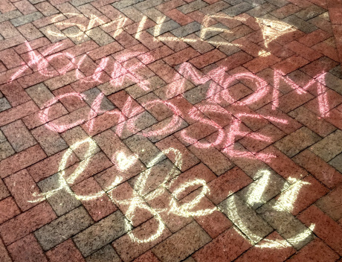
- We Don’t Need Planned Parenthood #DefundPP
- Abortion Hurts Women
- Women Need Love Not Abortion
- Restore Preborn Rights
- Human Rights for All: Born & Preborn
- Heart Begins Beating at 21 Days
- Social Justice Begins in the Womb
- Adoption Not Abortion
- Love Them Both
- True Feminists are Pro-Life
- Peace Begins in the Womb
- Equal Rights for Preborn People
- Draw 3,000 baby feet or hearts and chalk “Abortion Stops 3,000 Hearts Every Day.”
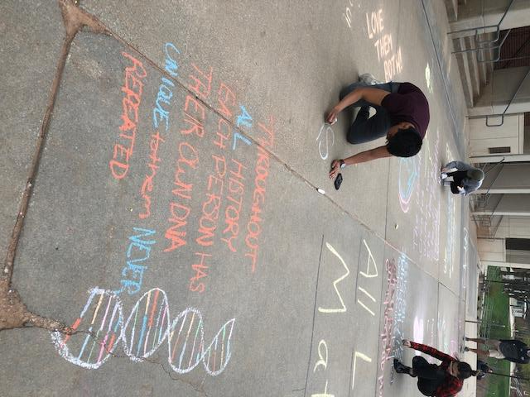
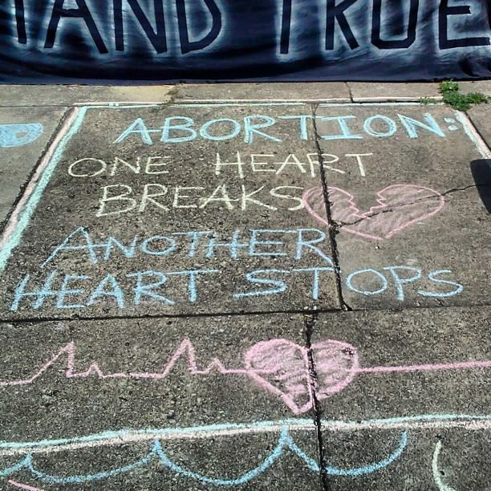
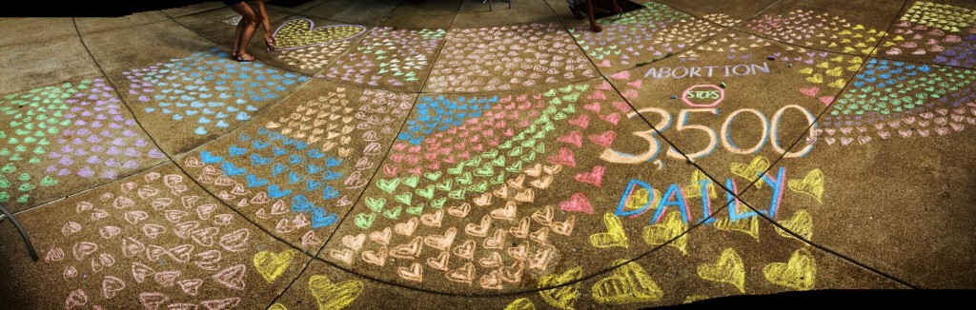

Fetal Development Facts:
- DNA is complete at conception.
- Fingerprints develop 6 weeks after being conceived.
- Most babies can smile just 11 weeks after conception.
- We’re all human from day one!
- Babies recognize their mother’s voice and native language because of what they hear in the womb
- Babies start to sleep 4 weeks from conception.
- Babies suck their thumbs before they are born!
- Babies yawn while in the womb.
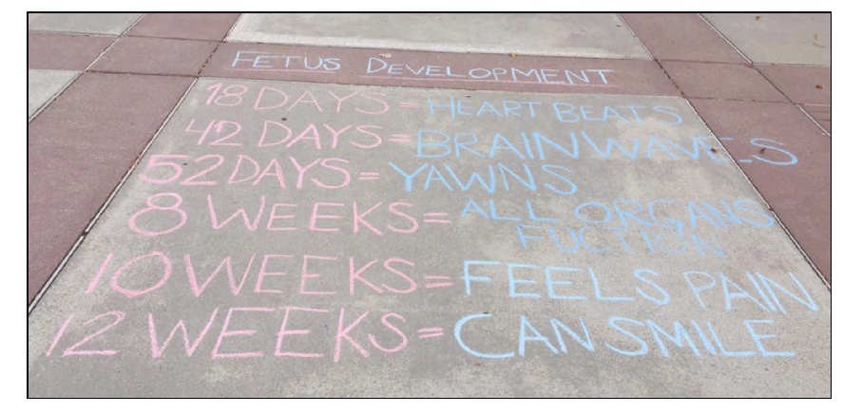
Facts from Prolife Across America:
- The average age of a woman who obtains an abortion is 18-26.
- One third of women who obtain an abortion are married.
- 59% of women obtaining abortions have at least one child.
- 62% of women obtaining abortions claim a religious affiliation. 24% said they were Catholic, 17% were mainline Protestant, 13% were evangelical Protestant and 8% identified with a different religion.
- 45% of women obtaining abortions have already had at least one previous abortion.
- 90% of those women who get an abortion say they did it to please someone else (husband, boyfriend, parents, friends, counselors, etc.).
- Abortion is the most frequently performed surgery in America.
- The U.S. abortion rate is among the highest of developed countries. Nearly 1 in 4 pregnancies in the U.S. end in abortion.
- Only seven states prohibit abortions for reason of sex selection, and only one state prohibits abortions for reasons of race.
(Sources: Centers for Disease Control and Prevention and e Guttmacher Institute)
Quotes:
- “Abortion is...
One more heart that will never beat again.
Two more eyes that will never see light.
Two more hands that will never touch or feel.
Two more legs that will never run for miles.
Two more lips that will never speak a word.
One more mouth that will never know a smile.”
― Queen Susan the Gentle's friend (The Chronicles of Narnia)

- “Saying that there are too many children is like saying there are too many flowers.” —Mother Teresa

- “I’ve noticed that everyone who is for abortion has already been born.” —Ronald Reagan

- “A person is a person no matter how small.” ―Dr. Seuss

- “Even the smallest person can change the course of the future.” ― Lord of the Rings Movie

- “It seems to me clear as daylight that abortion would be a crime.” – Gandhi

- “We’re all human, aren’t we? Every human life is worth the same, and worth saving.” – J.K. Rowling

- “The right to life is the first among human rights.” – Pope Francis

- “Give us the grace – When the sacredness of life before birth is attacked, to stand up and proclaim that no one ever has the authority to destroy unborn life.” – St. John Paul II

- “Before I formed you in the womb, I knew you; before you were born I sanctified you.”– St. Jeremiah 1:5

- “There are two victims in every abortion: a dead baby and a dead conscience.” – St. Mother Teresa

- “You have been my guide since I was first formed . . . from my mother’s womb you are my God” – Psalm 22:10-11

- “You are called to stand up for life! To respect and defend the mystery of life always and everywhere, including the lives of unborn babies, giving real help and encouragement to mothers in difficult situations. You are called to work and pray against abortion.” – St. John Paul II

- “Human life must be respected and protected absolutely from the moment of conception. From the first moment of his existence, a human being must be recognized as having the rights of a person – among which is the inviolable right of every innocent being to life.” – Catechism of the Catholic Church 2270

- “Life is a civil right. Abortion is a civil wrong.”― Alveda C. King

