LIFESPAN REPRESENTATIVE BULLETIN NOTES, JULY 2021

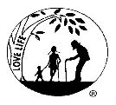

July 3, 4 Right to Life-LIFESPAN 4th of July
Our country was created because of a desire to be free—free to worship, free to speak, free to assemble and free to seek aid from our government. It was founded on the principle that we all have the right to life, liberty and the pursuit of happiness. There are times when we struggle to assure these rights, but we know that the Right to Life is fundamental to them all.

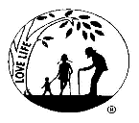

July 10,11 Right to Life-LIFESPAN Truth
“There are two ways to be fooled. One is to believe what isn’t true: the other is to refuse to believe what is true” Soren Kierkegaard Truth-----Human life begins at conception and ends with natural death.
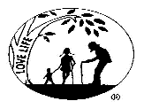
July 17. 18 Right to Life-LIFESPAN Conscience Protection
The Democratic Women’s Caucus and the Secular Democrats of America are pressuring Mr. Biden to eliminate the Conscience and Religious Freedom Division of the Office of Civil Rights. This division was created to ensure the federal enforcement of laws that exist to protect the fundamental right of conscience and religious freedom. Those who seek the removal of this protection claim that “it has been weaponized to justify discrimination”. It would seem that some seek the removal of rights guaranteed to all of us in the Constitution of the United Sates.

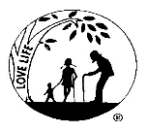
July21,22 Right to Life-LIFESPAN Answering Questions
If you have ever been stumped by a question asked of you from someone who supports abortion, here is the answer. Stuck, A Complete Guide to Answering Tough Questions About Abortion by Justina VanManen offers answers to the ‘gottcha’ questions those who support abortion like to ask of pro-lifers. Presented in an easy to read, well researched and factual format, this is one of the best books to come out since ProLife Answers to ProChoice Arguments. It is well worth your time.

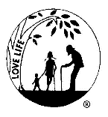
July 30, 31 Right to Life-LIFESPAN Pro Life Presence
If you travel this summer and see a sign or a billboard or a poster or a marquee displaying a
pro-life message, take a picture and send it to us at oakmac@rtl-lifepsan.org . We hope to get several of these and reprint them the LIFESPAN news proving that pro-life people are everywhere!!! Don’t forget to include the location of the sign.

