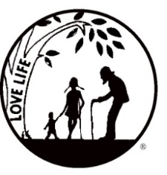
Presenting the Pro-Life Message in Southeastern Michigan Since 1970
Right to Life - LIFESPAN
Life is like an arch. If you discard one segment as worthless,
the span collapses — the value of all life brought low.
Please post fliers wherever possible and bring it to the attention of your pastor, youth group coordinators and pro-life groups.
www.miLIFESPAN.org August 12, 2019
March 31.
WALK FOR LIFE - SUNDAY, SEPTEMBER 15, 2019
2:00PM TO 3:30PM - SUMAC POINTE HINES DRIVE
PLEDGE FORMS AVAILABLE ONLINE OR AT OUR OFFICE
Hello, Champions!
I want to share with you some sad news but not bad news. I want to THANK Sharon Neal for her many years of service with LIFESPAN’s Wayne County Chapter. Sharon needs to take at least a year off to go and help her daughter whose husband will be deployed to Afghanistan for a year. Sharon will be helping with her grandchildren in Virginia. Blessings and may God watch over all of you and to your son- in-law. THANK YOU FOR YOUR SERVICE.
Just a reminder: please get the Walk for Life fliers out to your groups and also Saturday, October 19ths Pro-Life Luncheon at St. Aiden in Livonia. Some updates as I said in the last Church Notes. Joyce Hansen will be working with the Church Representatives. The Church notes this month have been written by Joyce. If you have any questions, please contact her in the office.
I am continuing looking for sponsors for the Walk for Life. The cost is $50.00 and we can print their Logo on the sign. These are great for advertising when the walkers pass by. I am also looking for some volunteers for the Walk. If interested, please call or email me.
The group at Planned Parenthood is still meeting to pray. Call our office for times - they are not publishing the schedule. Note: This Planned Parenthood has been told they MUST be PROFITABLE in two years or they will be CLOSED. Keep up the great work Pro-Life Michigan and all the prayer WARRIORS.
One last reminder: If you have not mailed your Church Rep questionnaire in yet, PLEASE DO. We need your help. If you need another, please call.
Keep on the path and enjoy the rest of your summer. Stay safe.

END DISMEMBERMENT ABORTIONS PETITION FORMS ARE AVAILABLE IN OUR OFFICE AND THE MAIN OFFICE.
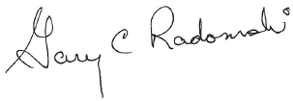
Yours in LIFE

Gary C Radomski
Director, Wayne County Chapter
Wayne County Chapter
32540 Schoolcraft Rd., Suite 210
Livonia, MI 48150-4305
email: wcdr@rtl-lifespan.org
734-422-6230 Fax 734-422-8111
www.miLIFESPAN.org

E-BOOKS ARE IN AND POST CARD REMINDERS WENT OUT ON 8-13-19

