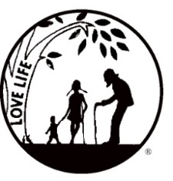
Presenting the Pro-Life Message in Southeastern Michigan Since 1970
Right to Life - LIFESPAN
Life is like an arch. If you discard one segment as worthless,
the span collapses — the value of all life brought low.
Please post fliers wherever possible and bring it to the attention of your pastor, youth group coordinators and pro-life groups.
www.miLIFESPAN.org August 1, 2019 31
WALK FOR LIFE - SEPTEMBER 15, 2019
2:00 PM TO 3:30PM SUMAC POINTE 37401 HINES DRIVE, LIVONIA PLEDGE FORMS AND FLIERS ARE IN THIS LETTER!

Hello, Champions!

It has been a very busy month in a half. I went to the National Right to Life Convention in Charleston, South Carolina with my wife and was very much impressed for my first convention. We learned a lot and brought back many ideas from other Right to Life groups which we hope to apply in our efforts here in Wayne County Chapter to further educating our communities about abortion and euthanasia. Just a reminder if you have not heard, we do have the END DISMEMBERMENT ABORTION petitions in all of our offices. PLEASE RETURN COMPLETED FORMS TO YOUR LOCAL LIFESPAN OFFICE.
As most of you know, Anne Marie has extended her role at LIFESPAN as Assistant Youth Director which she has been working at part-time along with running our Chapter Office for some time and even filling in for the Director until I was hired in January. Her help was greatly appreciated and I am so glad she will be downstairs at the Main Office as a reference as we move forward in our Chapter. We will have a new Office Manager starting August 21st. Her name is Eleanor Dolowy. She attends Schoolcraft College and is a graduate of St. Catherina’s of Siena in Wixom. She will be here about 15 hours a week. More on Ellie later. Our other new team member is Joyce Hansen. Joyce will be Director of Education, responsible for coordinating Church Representatives and Outreach of the Chapter. She started July 24th. She will also be writing the monthly Church Notes. More on Joyce in the coming months and Newsletters. I feel so blessed to have these two as part of the Wayne County Chapter Team. It was very hard decision: we had 14 well qualified applicants and with a lot of thought and prayer, I think all will be well.

PRO-LIFE LUNCHEON - SATURDAY OCTOBER 19, 2019
FEATURED SPEAKERS: ELLEN SALTER AND COUNCILMAN SCOTT BAHR
St. Aiden Church 17500 Farmington Rd. in Livonia
Call 734-422-6230 for more information

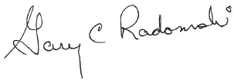
Yours in LIFE,

Gary C Radomski
Director, Wayne County/Downriver Chapter

Wayne County Chapter
32540 Schoolcraft Rd., Suite 210
Livonia, MI 48150-4305
email: wcdr@rtl-lifespan.org
734-422-6230 Fax 734-422-8116

www.miLIFESPAN.org

