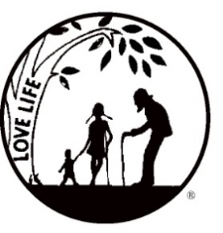
Presenting the Pro-Life Message in Southeastern Michigan Since 1970
Right to Life - LIFESPAN
Life is like an arch. If you discard one segment as worthless,
the span collapses — the value of all life brought low.
www.miLIFESPAN.org
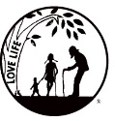
LIFESPAN Church Notes August 2019 (PAGE 1 of 1)
August 10-11: Right to Life - LIFESPAN IQ and Fathers

DID YOU KNOW? Numerous studies have found that children who grow up in a household with a father show superior outcomes in intelligence tests. This is particularly marked in the area of non-verbal (or spatial) reasoning—ways of thinking that are important in fields such as mathematics, science and engineering.
For more info: LIFESPAN 734.422.6230 www.miLIFESPAN.org

August 17-18: Right to Life – LIFESPAN The Power of Play: Thanks, Dad!

"In infants and toddlers, fathers' hallmark style of interaction is physical play that is characterized by arousal, excitement, and unpredictability," writes psychologist Ross Parke, who has conducted dozens of studies on fatherhood. Mothers do a lot, but don’t play the same way with their children. The type of play that a father provides helps with the child’s neurologic and social development. When children “roughhouse” with their father, they quickly learn that biting, kicking and hitting aren’t acceptable. Play on, Dads, play on!
For more info: LIFESPAN 734.422.6230 www.miLIFESPAN.org

August 24-25: Right to Life – LIFESPAN “EUTHANASIA” when the Doctor Kills the Patient!

They want to say and qualify euthanasia by calling it active or passive, direct or indirect, voluntary, involuntary, or assisted suicide only to confuse the picture. We need more people to know about care of the terminally ill, and the pros and cons of legal euthanasia. The more they know about it, the less they support it. Among doctors, support for euthanasia is strongest among those who know the least about it. Euthanasia advocates appeal to the fearful in the name of ideals of compassion and autonomy. But they promote policies which, despite their best intentions, can only result in coercion and cruelty. The target to dehumanize older people.
Call LIFESPAN 734.422.6230 www.miLIFESPAN.org

Save the Date! Walk for Life: September 15, 2019

Wayne County Chapter
32540 Schoolcraft Rd., Suite 210
Livonia, MI 48150-4305
email: wcdr@rtl-lifespan.org
734-422-6230 Fax 734-422-8116

