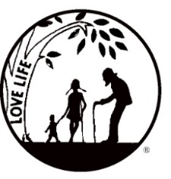
Presenting the Pro-Life Message in Southeastern Michigan Since 1970
Right to Life - LIFESPAN
Life is like an arch. If you discard one segment as worthless,
the span collapses — the value of all life brought low.
Please post fliers wherever possible and bring it to the attention of your pastor, youth group coordinators and pro-life groups.
www.miLIFESPAN.org June 18, 2019

Hello, Champions!

Hope all is well and you are ready for summer like me. They say it comes in a couple of days but we will see. For now, Mother’s Day, Garage Sale and Father’s Day are all behind us and we are hoping everyone was blessed on those two special days. Churches are still returning items from these sales. If you did not participate this year, consider doing so next year. As you know these are ways to keep us running and educating on our mission and saving lives.

If you have not heard, Anne Marie will be stepping down as Office Manager at the end of June. She will be expanding her responsibilities as the Associate Youth Director. Her office will be located in same building but downstairs at the Main Office in Ste. 100. This will be a great asset to Wayne County Youth. Anne Marie is very passionate about involving the youth more in the pro-life movement and with LIFESPAN. Please contact her at youth@milifespan.org to connect her with the youth at your parish or school.

Please Note: our office will be closed July 1st through July 14th. When we return we will start Summer Hours. Our summer hours will be Monday-Wednesday 9:00am to 2:00pm.

Bowling for Life: We are once again having the Bowling for Life event to get you out of the summer heat and together for some friendly competition. On Friday, July 26th, we will be at the Woodland’s Bowling Alley on Plymouth Road in Livonia from 7-9pm. Last year, we asked people to collect pledges. This year, there will be a flat rate: $25 for adults and $15 for students 21 or younger. Participants will get will two games of bowling, pop, pizza, 2 mystery games, and opportunities to win raffle baskets or the 50/50!

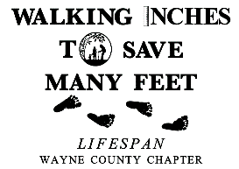
Walk for Life: We are working on setting up our Walk for Life again this year.
It will be Sunday, September 15th in Hines Park, near Newburgh Road. Please encourage everyone to collect pledges and to come out for a beautiful walk that supports a beautiful thing: LIFE! We will be witnesses for LIFE by wearing t-shirts that advertise our cause. Please check out all the information we have enclosed in this mailing.

Yours in LIFE,
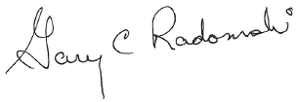

Gary C. Radomski
Director, Wayne County/Downriver Chapter

Wayne County Chapter
32540 Schoolcraft Rd., Suite 210
Livonia, MI 48150-4305
email: wcdr@rtl-lifespan.org
734-422-6230 Fax 734-422-8116

www.miLIFESPAN.org

