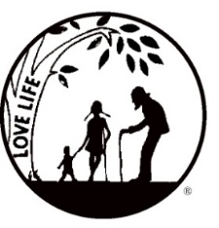
Presenting the Pro-Life Message in Southeastern Michigan Since 1970
Right to Life - LIFESPAN
Life is like an arch. If you discard one segment as worthless,
the span collapses — the value of all life brought low.
Please post fliers wherever possible and bring it to the attention of your pastor, youth group coordinators and pro-life groups.
www.miLIFESPAN.org May 22, 2019

Hello, Champions!

Please welcome Ron Reed, our new treasurer. Thank You for stepping up and volunteering! Ron’s experience in finance will be a great asset to the Chapter and LIFESPAN and is already paying great dividends. He has been able to help us get a working budget and find things that we can work on so we continue to function and keep our Chapter running.
THANK YOU: Garage Sale: Our garage sale is complete for this year. Thank God the weather held out and we were able to get this year in without a hitch. I can give you an estimate of $2,500.00 profit. A Big Thank you to all the volunteers who pitched in to make this year’s sale a success. Special Thanks to Ray and Jane for the use of their yard, barn, and garage. Also, Anne Marie, who worked so hard coordinating all the functions and Pat H. for your scheduling. Thanks all who made purchases, which supports our Chapter’s work.

THANK YOU: Mother’s Day: Thank You to all who participated this year! Stay tuned for a final report for Mother’s Day next month along with Father’s Day.
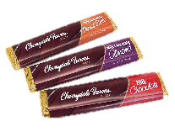
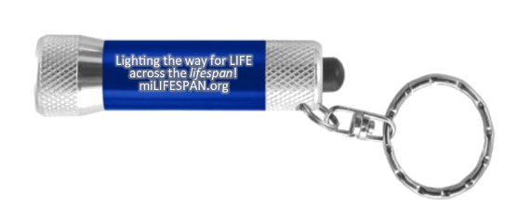
Father’s Day: Pens with a stylus tip (“Thanks, Dad, for Life! Happy Father’s Day”), chocolate bars, tape measures, and stands for phones/tablets will all be available for donations. The candy bars will all be labelled with the phrase “Life is Sweet, Thanks for LIFE!” and one of these facts about human development with a cute baby picture.
NEW THIS YEAR: Father’s Day Flashlights!
These flashlights are labelled with the phrase “Lighting the way for LIFE across the lifespan!” Light up Father’s Day by giving these pro-life flashlights to the amazing men in our lives!

Bowling for Life: We are once again having the Bowling for Life event to get you out of the summer heat and together for some friendly competition. On Friday, July 26th, we will be at the Woodland’s Bowling Alley on Plymouth Road in Livonia from 7-9pm. Last year, we asked people to collect pledges. This year, there will be a flat rate: $25 for adults and $15 for students 21 or younger. Participants will get will two games of bowling, pop, pizza, and opportunities to win raffle baskets or the 50/50!

Yours in LIFE,
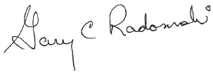

Gary C. Radomski
Director, Wayne County/Downriver Chapter

Wayne County Chapter
32540 Schoolcraft Rd., Suite 210
Livonia, MI 48150-4305
email: wcdr@rtl-lifespan.org
734-422-6230 Fax 734-422-8116

www.miLIFESPAN.org

