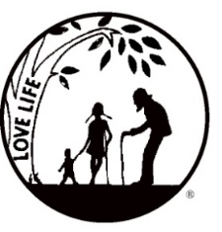
Presenting the Pro-Life Message in Southeastern Michigan Since 1970
Right to Life - LIFESPAN
Life is like an arch. If you discard one segment as worthless,
the span collapses — the value of all life brought low.
Please post fliers wherever possible and bring it to the attention of your pastor, youth group coordinators and pro-life groups.
www.miLIFESPAN.org January 15, 2019
The Wayne County Chapter
has a new director!

Hello, Everyone!

I would like to introduce myself. My name is Gary C. Radomski and I am the NEW Wayne County Chapter Director. I officially started January 7. My wife Barbara and I have been married for 47 ½ years & we have two grown children, Gary R. and Nicole Miller. We also have 5 grandchildren. We lived in Dearborn Heights for 37 years and then moved to South Lyon for 2 ½ years. Presently, we are residing in Livonia which is much closer to the kids and grandkids. This makes things much easier for all of us and we are thrilled to be in Livonia. Here in Livonia, Barb and I are members of St. Michael’s Parish. For the past 30 years Barb has worked at the Livonia Senior Center as a bus driver.
I retired from Ford Motor Company in 2002, where I worked management roles in different departments and worked hourly. I am also a retired UAW member. After Ford, I went to work for the Archdiocese of Detroit. The jobs I held were Youth Minister, Pastoral Associate and Christian Service Director at various parishes. In 2015, I retired from St. Joseph’s Parish in South Lyon, where I was involved with the Knights of Columbus and served as Deputy Grand Knight.
My passion for over 50 years has been coaching and working with youth. I coached football and still am coaching Track at Stevenson High School in Livonia. Along with the coaching, I served as an Athletic Director at grade school and high school levels. These positions and responsibilities will help me as the Wayne County Director by organizing, taking responsibility, inspiring others, budgeting, fundraising, hiring and training as needed.
Over the years, I have worked with Right to Life groups. I’ve held a sign for the Life Chain, said rosaries for life and have always had a passion to do more to save the unborn. I strive to educate others that abortion is not the answer and there is help out there.
I just want to say THANK YOU to Diane Fagelman and the Wayne County Board for giving me this opportunity; a new ministry. Most importantly, I want to thank God for answering my prayers and leading me to this Great organization. Thank you all for what you ALL do to promote and respect for human life from conception to natural death.
Once I get my boots on the ground, like we said in the Army, I am hoping to contact each church representative and would like to meet with you one on one. Please feel free to call me at the office anytime.

Yours in LIFE,
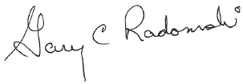

Gary C. Radomski
Director, Wayne County/Downriver Chapter

Wayne County Chapter
32540 Schoolcraft Rd., Suite 210
Livonia, MI 48150-4305
email: wcdr@rtl-lifespan.org
734-422-6230 Fax 734-422-8116

www.miLIFESPAN.org

