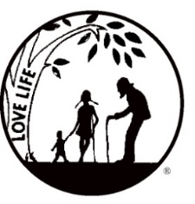
Presenting the Pro-Life Message in Southeastern Michigan Since 1970
Right to Life - LIFESPAN
Life is like an arch. If you discard one segment as worthless,
the span collapses — the value of all life brought low.
www.miLIFESPAN.org
LIFESPAN Church Notes February 2019 (PAGE 1 of 2)

February 2-3: Right to Life - LIFESPAN March for Life, Movement in Motion
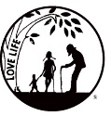
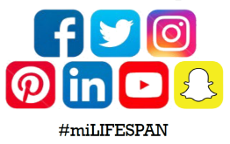
Did you know? The March for Life was Friday, January 18th this year? LIFESPAN sent 8 buses! They left for Washington D.C. on Thursday, January 17th at 6pm and returned on Sunday, January 19th around 6am. Groups who participated in LIFESPAN’s Movement in Motion were: Mercy High School, Brother Rice High School, U of D Jesuit High School, Austin Academy, Saint Catherine of Siena Academy, Our Lady of the Lakes High School, Our Lady of Good Counsel Jr. High School, St. Mary Monroe/Catholic Central High School, Regina High School, FISH, and Saints Cyril and Methodius parish. Take a look at our social media platforms to see some of our coverage of the March for Life!

For more info: LIFESPAN 734.422.6230 www.miLIFESPAN.org

February 9-10: Right to Life – LIFESPAN Luminaries
This year’s luminary kit distribution was very successful. We passed out over 2,000 luminaires to around 25 churches and numerous individuals. They were assembled by such wonderful volunteers. These volunteers made it possible for the luminaries to be available for parishes to light the streets of metro Detroit in memory of nearly 61 million lives lost to abortion since the decision of Roe v. Wade in 1973. If you did not participate this year and would like to next year, please call the Wayne County Chapter and sign up for our Luminary Participant List.
For more info: LIFESPAN 734.422.6230 www.miLIFESPAN.org

Please Turn Over

Wayne County Chapter
32540 Schoolcraft Rd., Suite 210
Livonia, MI 48150-4305
email: wcdr@rtl-lifespan.org
734-422-6230 Fax 734-422-8116

www.miLIFESPAN.org

Presenting the Pro-Life Message in Southeastern Michigan Since 1970
Right to Life - LIFESPAN
Life is like an arch. If you discard one segment as worthless,
the span collapses — the value of all life brought low.

LIFESPAN Church Notes February 2019 (PAGE 2 of 2)

February 16-17: Right to Life – LIFESPAN Defunding Abortion
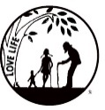
Did you know? Congresswomen Virginia Fox of North Carolina has filed legislation that would revoke Planned Parenthood’s taxpayer funding via the Title to Family Planning Program. The bill is H.R. 296, and the Defunding of Planned Parenthood Act of 2019 respectively. It is Clear abortion is not family planning. Title X grants to family planning entities not abortion providers. The Title X Abortion Provider Prohibition Act will keep it this way. The bill would codify President Trump’s Protect Life Rule that excludes abortion providers, including Planned Parenthood, from receiving Title X funding. This legislation would ban taxpayer funding.
For more info: LIFESPAN 734.422.6230 www.miLIFESPAN.org

SAVE THE DATE: Sunday, March 10th is the official kickoff date of LIFESPAN’s 30th Annual Baby Shower.
Each church/organization is assigned to one of the over twenty PHCs that need your donations! Is your church participating? If not, check our website or call our office for a listing of local LIFESPAN Baby Showers.

February 23-24: Right to Life - LIFESPAN Planned Parenthood in Livonia
Conscience: God’s voice guiding us in our hearts. The role of conscience in moral decision making is central in the Life Movement as we all know. We must be attuned to God’s voice and follow our conscience. With that in mind, I would like to remind everyone that Planned Parenthood is now open at 15707 Farmington in Livonia. There is a strong force for Life praying on the sidewalk and this force will continue until this issue and the closing of the clinic is complete. Please join the force, we need physical presents. Yes, it is cold but one hour will make a difference.
For more info: LIFESPAN 734.422.6230 www.miLIFESPAN.org

SAVE THE DATE: Sunday, March 10th is the official kickoff date of LIFESPAN’s 30th Annual Baby Shower.
Each church/organization is assigned to one of the over twenty PHCs that need your donations! Is your church participating? If not, check our website or call our office for a listing of local LIFESPAN Baby Showers.

