***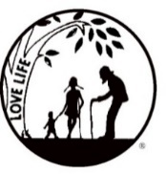****Presenting the Pro-Life Message in Southeastern Michigan Since 1970*

***Right to Life - LIFESPAN***

Life is like an arch. If you discard one segment as worthless,

the span collapses — the value of all life brought low.

*Please post fliers wherever possible and bring it to the attention of your pastor, youth group coordinators and pro-life groups.*

*www.miLIFESPAN.org October 16,* 2018

Hello, Everyone!

It is with a heavy heart that I share with you the resignation of our beloved Director, Eileen Brandt.

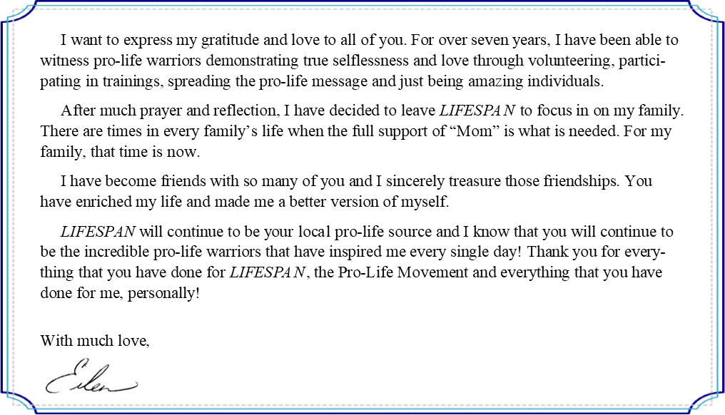

Even though Eileen will be missed, we must carry on. Check out what we have instore for this month and months to come below:

**Candidate Survey:** Make sure that you share the October LIFESPAN Newsletters which contain the results of our candidate survey. We want to make sure that everyone has the answers to questions about pro-life issues from candidates that are in your area. We know that you will be able to choose the candidates who best match your principles. The candidate responses will still help you for November’s ballot—make sure that your church has copies available for parishioners!

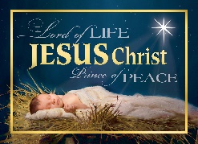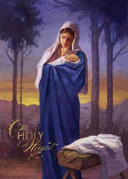

**Christmas Cards** are available! Please find a weekend or two (or more!) to offer our cards to your faith community. If you have never done this before, please consider giving it a try. There is no cost to your faith community; all cards come to you “on consignment”. It requires a few volunteers, a couple of announcements in your church papers and one or two weekends after services. We need everyone’s help as **this is our biggest fundraiser**. Have questions? Call/email our office; we are happy to help!



**Entertainment Books:** This fundraiser supports *LIFESPAN* and saves YOU money! When you purchase a 2019 book for $30 you also receive a 2018 book (while supplies last). They are available on a first come-first serve basis. Get yours today!

**Sign Painting Party:** Saturday, November 3, 2018, 10AM-12PM. Save the date and plan on joining us for a sign painting party that will help you decorate your home or create a perfect gift for a loved one!

**Lights for Life:** Every year we light a 14 foot tall Christmas tree at Weingartz in Farmington Hills to honor LIFE. Help us light up the tree by sending in a donation to remember or honor loved ones!

 Yours in LIFE,

[wcdr@rtl-lifespan.org](mailto:wcdr@rtl-lifespan.org)

734.422.6230 Fax: 734.422.8116

***www.miLIFESPAN.org***

Anne Marie Morin

Associate Youth Director

Office Manager, Wayne County Chapter

Wayne County Chapter, 32540 Schoolcraft Rd., Ste. 210, Livonia, MI 48150-4305