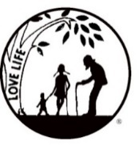
Presenting the Pro-Life Message in Southeastern Michigan Since 1970
Right to Life - LIFESPAN
Life is like an arch. If you discard one segment as worthless,
the span collapses — the value of all life brought low.
Please post fliers wherever possible and bring it to the attention of your pastor, youth group coordinators and pro-life groups.
www.miLIFESPAN.org September 11, 2018

Hello, Everyone!
I can’t believe I am sending you the October Church Notes, already! Thank you to everyone who supported Bowling for Life--what a fun evening! We will plan on another Bowling for Life, possibly in the winter months to help everyone beat cabin fever or next summer, again to beat the heat. For now, get out and soak up every bit of sun and warmth that you can!

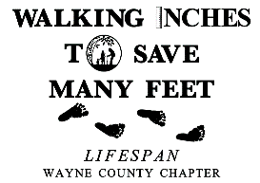
Walk for Life: Last year, Channel 4 came out to check us out. We want to have a HUGE crowd, especially if the media comes out to see us again. The walk is THIS Sunday, September 16th and will be held at same spot in Edward Hines Park at Sumac Pointe (the first site west of Newburgh Road in Livonia. If you can’t walk, we can designate a walker to walk in your honor!

Church Rep Meeting: YOU are invited!!!! Make sure and call in to let us know that you can attend our Fall Church Rep Meeting on Sunday, Sept. 30th. Please consider inviting your pastor/priest, youth group coordinator, etc. from your parish—we would love to meet them and answer any questions! Call our office to RSVP or if you have any questions!

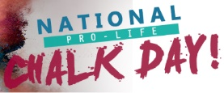
National Pro-Life Chalk Day: Thursday, October 4th: Every year, on the first Thursday of March and October, the pro-life message reaches hundreds of thousands of people in the simplest of ways, sidewalk chalking. This small but powerful tool has been used to share the truth about abortion, get the word out about pregnancy resources, and help men and women who have had experiences with abortion find help and healing. And it’s FUN! With a handful of chalk and an arsenal of pro-life slogans, you can leave a lasting impression on hundreds or even thousands of people. Call our office for more information!
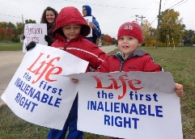
LIFE CHAIN: Sunday, October 7th: Check LIFESPAN’s listing of confirmed locations of LIFE CHAINS in the Metro Detroit area. Is your church/organization registered as a co-sponsor? If not, please consider registering to co-sponsor a LIFE CHAIN location. This is an easy way to be a pro-life witness and LIFESPAN provides approved LIFE CHAIN signs, on request.

Pro-Life Luncheon: Saturday, October 13th: Please advertise and plan on attending this important event! Whether you are seeking healing or know of someone who has had an abortion and is suffering—there is HOPE and there is HEALING! Pro-Life People don’t need to shame or hurt those who carry the burden of an abortion but instead support them because they have (and probably still are) suffering. There are resources and support available. Legislative updates will also be provided.

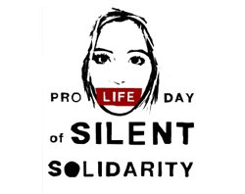
PRO-LIFE DAY OF SILENT SOLIDARITY: Tuesday, October 17th, many students will give up their voices for the Pro-Life Day of Silent Solidarity. Representing the 3,000 voices taken by abortion every day, these students choose to take a vow of silence and wear a red armband. Use #ProLifeDayOfSilentSolidarity and #miLIFESPAN to post on social media.

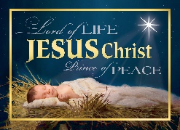
Christmas Cards: It may seem too early to even be thinking of Christmas Cards, but we have already designed and ordered two new selections for this year. We should have them in the office somewhere around the last week of September. We offer an assortment of Christmas Cards on a consignment basis. Can you get a few volunteers to man a table after services for one or two weekends? People like to purchase LIFESPAN’s Christmas Cards because they are beautiful, high-quality, religious-themed cards that really brighten the recipient’s day and are a gift of LIFE because they support LIFESPAN. This is our largest fundraiser of the year and we really need YOUR help to make it a success. Have questions? Please call/email our office; we are happy to help!
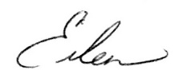
Yours in LIFE,
wcdr@rtl-lifespan.org
734.422.6230 Fax: 734.422.8116
www.miLIFESPAN.org

Eileen Brandt
Director, Wayne County/Downriver Chapter
Wayne County Chapter, 32540 Schoolcraft Rd., Ste. 210, Livonia, MI 48150-4305

