***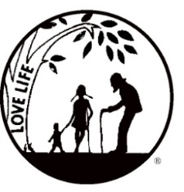****Presenting the Pro-Life Message in Southeastern Michigan Since 1970*

***Right to Life - LIFESPAN***

Life is like an arch. If you discard one segment as worthless,

the span collapses — the value of all life brought low.

*Please post fliers wherever possible and bring it to the attention of your pastor, youth group coordinators and pro-life groups.*

*www.miLIFESPAN.org August 8,* 2018

Hello, Everyone!

**Bowling for Life:** We are bringing back a fun event to get you out of the summer heat and together for some friendly competition. On Friday, August 17th, we will be at the Woodland’s Bowling Alley on Plymouth Road in Livonia from 7-9pm. We are asking people to collect pledges and there will be some raffle baskets that can be won. $15 in pledges or more (*please get more pledges!*) will get each participant two games of bowling, pop, pizza. Be sure to post the flier and forms and come out for some fun!

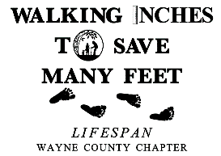**Walk for Life:** We are working on setting up our Walk for Life again this year. Last year, Channel 4 came out to check us out. We want to have a HUGE crowd, especially if the media comes out to see us again. Our date is Sunday, September 16th and will be held at same spot in Edward Hines Park at Sumac Pointe (the first site west of Newburgh Road in Livonia. If you can’t walk, we can designate a walker to walk in your honor!



Conference: **ABORTION PILL REVERSAL — It May Not Be Too Late A certificate of attendance is available for nurses. The public is welcome and encouraged to attend the MNFL Conference. SATURDAY, SEPTEMBER 15, 2018 Location:** St. Joseph Mercy Oakland, Pontiac. SPEAKERS: **Dr. George Delgado, M.D. Tracey Fish, MS, PA-C** and **Kirstie Almy, MS, PA. Pre-registration required.**

**National Day of Remembrance: Saturday, September 8, 2018. Join us for a brief, but powerful ceremony at White Chapel Cemetery in Troy. We will remember the five babies who were killed by abortion that LIFESPAN provided a proper burial for back in 1980 and all of the innocent babies who have been killed in the United States by abortion since 1973.**

**LIFE CHAIN:** Check LIFESPAN’s listing of confirmed locations of LIFE CHAINS in the Metro Detroit area. Is your church/organization registered as a co-sponsor? If not, please consider registering to co-sponsor a LIFE CHAIN location. This is an easy way to be a pro-life witness and LIFESPAN provides approved LIFE CHAIN signs on request.

**Pro-Life Luncheon:** Please advertise this important event! Whether you are seeking healing or know of someone who has had an abortion and is suffering—there is HOPE and there is HEALING! Pro-Life People don’t need to shame or hurt those who are already suffering under the pain of abortion—we need to support those who carry the burden of an abortion because they have (and probably still are) suffering. There are resources and support available. Legislative updates will also be provided.

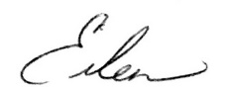 Yours in LIFE,

Eileen Brandt

Director, Wayne County/Downriver Chapter

**Wayne County Chapter**

32540 Schoolcraft Rd., ***Suite 210***

Livonia, MI 48150-4305

email: wcdr@rtl-lifespan.org

734-422-6230 Fax 734-422-8116

***www.miLIFESPAN.org***