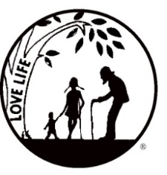
Presenting the Pro-Life Message in Southeastern Michigan Since 1970
Right to Life - LIFESPAN
Life is like an arch. If you discard one segment as worthless,
the span collapses — the value of all life brought low.
www.miLIFESPAN.org
LIFESPAN Church Notes July 2018 (PAGE 1 of 2)
July 7-8: Right to Life - LIFESPAN A Moral Stand that Created Our Country
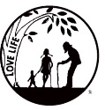
DID YOU KNOW? As pro-lifers, sometimes we are ill-treated by the pro-aborts, the media, the legal system, even friends/family and it hurts. We have taken a moral stand and we persevere. This month, we celebrate our country’s birth and the many opportunities it has bestowed on its citizens. What was the fate of the 56 signers of the Declaration of Independence who also took a stand and persevered? Our country depended on their stance and perseverance.
The 56 signers pledged their lives, their fortunes and their sacred honor. It was no idle pledge. Many hardships were faced by the signers including: injury, being jailed, loss of homes/fortunes, etc. No signers defected—their honor, like their nation, remained intact.
Pro-lifers have 56 great role models to follow as we take our moral stand and persevere.
For more info: LIFESPAN 734.422.6230 www.miLIFESPAN.org
SAVE THE DATES: Bowling for LIFE: August 17th Walk for Life: September 16th

July 14-15: Right to Life – LIFESPAN LIFE Matters and There Is Hope!
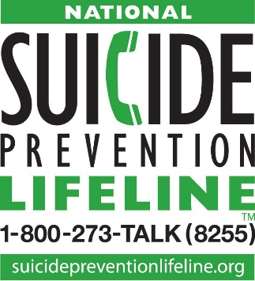
Recently, there have been reports in the media about some celebrities who have taken their own lives. These deaths are tragic and a sign of a larger cultural issue. Our culture has glorified “choice” and forgotten that ALL LIFE matters! The media remains silent about the elderly/sick /disabled who are told that they are worthless and that they should consider assisted suicide, or even worse, the elderly/sick/disabled whose lives are just taken through euthanasia including denying water and starvation. We must keep spreading the message that LIFE matters and there is always hope!
If you or someone you know is considering suicide, please get in touch and call the Lifeline. National Suicide Prevention Lifeline 1-800-273-8255.
If someone you know is at immediate risk of self-harm, call 911.
For more info: LIFESPAN 734.422.6230 www.miLIFESPAN.org
SAVE THE DATES: Bowling for LIFE: August 17th Walk for Life: September 16th

Please Turn Over

Wayne County Chapter
32540 Schoolcraft Rd., Suite 210
Livonia, MI 48150-4305
email: wcdr@rtl-lifespan.org
734-422-6230 Fax 734-422-8116

www.miLIFESPAN.org

Presenting the Pro-Life Message in Southeastern Michigan Since 1970
Right to Life - LIFESPAN
Life is like an arch. If you discard one segment as worthless,
the span collapses — the value of all life brought low.
LIFESPAN Church Notes July 2018 (PAGE 2 of 2)

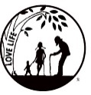
July 21-22 : Right to Life - LIFESPAN A Pro-Life Vacation
DID YOU KNOW? Before you book your vacation, be aware of which corporations support Planned Parenthood. You can decide with your money which businesses you support. One of these corporations is: Marriott—Operations (hotels/resorts: Autograph Collection (AC), Bulgari, Courtyard, Edition, ExecuStay, Fairfield Inn, Gaylord, Grand Residences, Horizons, Renaissance, Residence Inn, Ritz-Carlton, SpringHill Suites, TownePlace Suites). Write: Mr. Arne M. Sorenson, President and CEO, Marriott International Corp., 10400 Fernwood Rd., Bethesda, MD 20817, Phone: 800-450-4222, (301)380-3000, Facebook:/MarriottInternational, Twitter: MarriottIntl Source: The Boycott List; Life Decisions International
For more info: LIFESPAN 734.422.6230 www.miLIFESPAN.org
SAVE THE DATES: Bowling for LIFE: August 17th Walk for Life: September 16th

July 28-29 : Right to Life - LIFESPAN What do Pro-Lifers Stand For?
We are for the propositions that human life is good, that life is worth living and that life deserves respect and protection. We are for the proposition that every human being has an equal worth and dignity—that every human being has a right to live.
The worth of a human being does not depend on age, size, ability, dependency, state of development or the desires/decisions of others. The big are no more valuable than the small. The strong have no more rights than the weak. The independent do not matter more than the vulnerable and needy. All innocent human life should be respected and protected, from conception until natural death. It is simple: LIFE matters!
For more info: LIFESPAN 734.422.6230 www.miLIFESPAN.org
SAVE THE DATES: Bowling for LIFE: August 17th Walk for Life: September 16th

Wayne County Chapter
32540 Schoolcraft Rd., Suite 210
Livonia, MI 48150-4305
email: wcdr@rtl-lifespan.org
734-422-6230 Fax 734-422-8116
www.miLIFESPAN.org

