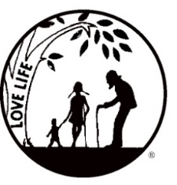
Presenting the Pro-Life Message in Southeastern Michigan Since 1970
Right to Life - LIFESPAN
Life is like an arch. If you discard one segment as worthless,
the span collapses — the value of all life brought low.
Please post fliers wherever possible and bring it to the attention of your pastor, youth group coordinators and pro-life groups.
www.miLIFESPAN.org June 14, 2018

Hello, Everyone!
Summer has arrived and so have our summer hours here at the office. We will be open Tuesday – Thursday from 10 am – 2 pm. The office will be closed on Monday and Friday. As always, appointments are available outside of posted hours.

You are truly an amazing group of people and we are so grateful to each and every one of you for all that you do so much to ensure that LIFE is respected across the entire lifespan!

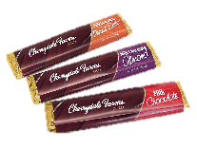
Father’s Day: Pens with a stylus tip (“Thanks, Dad, for Life! Happy Father’s Day”), chocolate bars, tape measures, and stands for phones/tablets will all be available for donations. The candy bars will all be labelled with the phrase “Life is Sweet, Thanks for LIFE!” and facts about human development with a cute baby picture. We are thrilled that DARK CHOCOLATE bars are included this year! Thank you to all who have volunteered to collect donations this weekend! Happy Father’s Day to all of the Fathers and Father-figures!
Bowling for Life: We are bringing back a fun event to get you out of the summer heat and together for some friendly competition. On Friday, August 17th, we will be at the Woodland’s Bowling Alley on Plymouth Road in Livonia from 7-9pm. We are asking people to collect pledges and there will be some raffle baskets that can be won. $15 in pledges or more (please get more pledges!) will get each participant two games of bowling, pop, pizza. Stay tuned for more information and forms!

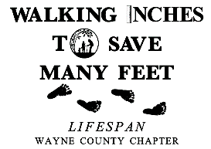
Walk for Life: We are working on setting up our Walk for Life again this year. Last year, Channel 4 came out to check us out. We want to have a HUGE crowd, especially if the media comes out to see us again. Our target date is Sunday, September 16th and we are working on reserving the same spot in Edward Hines Park. Once we get final approval, we will send you more information, but, please, save the date!

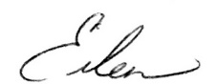
Yours in LIFE,

Eileen Brandt
Director, Wayne County/Downriver Chapter

Wayne County Chapter
32540 Schoolcraft Rd., Suite 210
Livonia, MI 48150-4305
email: wcdr@rtl-lifespan.org
734-422-6230 Fax 734-422-8116

www.miLIFESPAN.org

