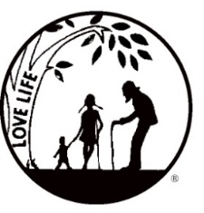
Presenting the Pro-Life Message in Southeastern Michigan Since 1970
Right to Life - LIFESPAN
Life is like an arch. If you discard one segment as worthless,
the span collapses — the value of all life brought low.
Please post fliers wherever possible and bring it to the attention of your pastor, youth group coordinators and pro-life groups.
www.miLIFESPAN.org May 21, 2018

Hello, Everyone!

THANK YOU: Mother’s Day: We had such a great response from the chocolate Mother’s Day roses! Thank you for all who participated! If your parish didn’t participate, but you are interested in the chocolate roses for Mother’s Day NEXT YEAR, please let our office know so that we can plan for next year. We still have some chocolate roses available, so if you want to give out somethings to teachers or parish members to thank them for all that you do, please call our office and reserve the number you need! If you are one of my sons’ teachers…just act surprised when you get the gift of chocolate roses!

THANK YOU: Garage Sale: Thank you so much to everyone who came out and helped to work at the garage sale. A special thank you to Ray and Jane Jakubiec; you open your home, yard, barns and your hearts—you make this possible! We brought in more money than last year and it was a great success. We couldn’t have done it without all of your help! We brought in close to $3,000 and people walked away with smiles and treasures.
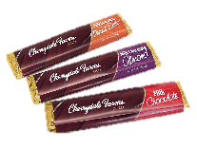
Father’s Day: Pens with a stylus tip (“Thanks, Dad, for Life! Happy Father’s Day”), chocolate bars, tape measures, and stands for phones/tablets will all be available for donations. The candy bars will all be labelled with the phrase “Life is Sweet, Thanks for LIFE!” and facts about human development with a cute baby picture.
Bowling for Life: We are bringing back a fun event to get you out of the summer heat and together for some friendly competition. On Friday, August 17th, we will be at the Woodland’s Bowling Alley on Plymouth Road in Livonia from 7-9pm. We are asking people to collect pledges and there will be some raffle baskets that can be won. $15 in pledges or more (please get more pledges!) will get each participant two games of bowling, pop, pizza. Stay tuned for more information and forms!

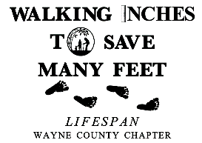
Walk for Life: We are working on setting up our Walk for Life again this year. Last year, Channel 4 came out to check us out. We want to have a HUGE crowd, especially if the media comes out to see us again. Our target date is Sunday, September 16th and we are working on reserving the same spot in Edward Hines Park. Once we get final approval, we will send you more information, but, please, save the date!

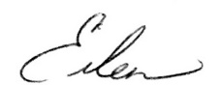
Yours in LIFE,

Eileen Brandt
Director, Wayne County/Downriver Chapter

Wayne County Chapter
32540 Schoolcraft Rd., Suite 210
Livonia, MI 48150-4305
email: wcdr@rtl-lifespan.org
734-422-6230 Fax 734-422-8116

www.miLIFESPAN.org

