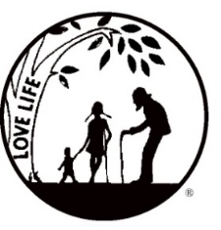
Presenting the Pro-Life Message in Southeastern Michigan Since 1970
Right to Life - LIFESPAN
Life is like an arch. If you discard one segment as worthless,
the span collapses — the value of all life brought low.
Please post fliers wherever possible and bring it to the attention of your pastor, youth group coordinators and pro-life groups.
www.miLIFESPAN.org December 15, 2017
Hello, Everyone!
Thank you to all of you who sold Christmas Cards! This is our largest fundraiser of the year and we really appreciate your support! So glad that some of you were able to attend our Christmas gathering—the food was amazing, but the fellowship was even better! Tons of things happening:
Movement in Motion Bus Trip: LIFESPAN’s Movement in Motion Bus Trip will soon be heading to Washington, D.C. for January’s March for Life. Make sure to watch EWTN for the best coverage of the March for Life and turn to mainstream media to see if they provide any coverage of this amazing event!
Also, check in on social media. The hashtag #miLIFESPAN will be used on the images and videos that are shared from the youth who are the bus trip. The following are the social media sites that we use:
Rose Ceremony: This moving ceremony that commemorates the 45th anniversary of the devastating Roe v. Wade decision and honors the nearly 60 million lives lost through abortion will be held at Our Lady of Good Counsel on Wednesday, January 24th at 6 PM. Rosary starts at 5:30 PM, with the Mass at 6PM.
LIFESPAN’s Luminaries: We have candle kits all set up. This is a beautiful way to memorialize the nearly 60 million babies that have lost their lives due to abortion. These luminaries are put out for donation at area churches. People light the luminaries the evening of January 21st. Have questions? Call our office!
A Night of Hockey! Please join us for a fundraiser and fun—all in one! As long as we sell 35 tickets, we earn a percentage of each ticket sold; if we sell 50 or more tickets, we earn a larger percentage. What can be better than a great night of hockey, fellowship and fun? We might even be able to have the funds from “chuck-a-puck”. The tickets are only $10 and we will have them in the office. You can either pick up your tickets at our office or we will meet you at the arena on Feb. 2nd and give them to you before the game.

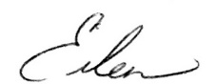
Yours in LIFE,

Eileen Brandt
Director, Wayne County/Downriver Chapter

Wayne County Chapter
32540 Schoolcraft Rd., Suite 210
Livonia, MI 48150-4305
email: wcdr@rtl-lifespan.org
734-422-6230 Fax 734-422-8116

www.miLIFESPAN.org

