***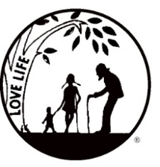****Presenting the Pro-Life Message in Southeastern Michigan Since 1970*

***Right to Life - LIFESPAN***

Life is like an arch. If you discard one segment as worthless,

the span collapses — the value of all life brought low.

*Please post fliers wherever possible and bring it to the attention of your pastor, youth group coordinators and pro-life groups.*

*www.miLIFESPAN.org November 14*, 2017

Hello, Everyone!

Thank you to all of you who are selling Christmas Cards; please let us know if there is anything we can do to support you. We had a great time at the Sign Painting Party! Thank you to Pastor Sam Watters at Living Word Church and Kara from Crafty Puzzle for running this event; everyone had a great time and wanted to know when we were scheduling the next party! The answer is after the new year. ☺ Tons of things happening:

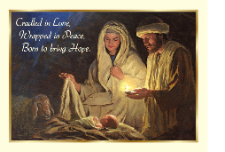

**CHRISTMAS CARDS ARE HERE!** They have arrived!!! Please call and set up an appointment to come and pick up the cards to offer at your church/organization. These religious cards are a great way to let people know that you are thinking of them and sending them Christmas Blessings!

*Please be sure to speak to your pastor and the editor of your church bulletin and*

*ask them to include our December church notes.*

**Entertainment Books ARE IN!!!**

This fundraiser supports LIFESPAN and saves YOU money! We are almost out of the 2017 books that you get free when you purchase the 2018 book for $30. Get yours now! They are available on a first come-first serve basis. These make a great gift for loved ones at Christmas that allows them to save money all year long!



**Lights for Life!** Be sure to help us light our 14 foot tree! Celebrate with us this Christmas Season, remembering those you love. In keeping with the Christmas spirit of giving, caring and sharing, LIFESPAN invites you to help illuminate our “Lights for Life” Tree by donating a light in honor of, or in memory of, someone you love. More details enclosed.



***Movement in Motion*** Bus Trip: LIFESPAN’s Movement in Motion Bus Trip will soon be heading to Washington, D.C. for January’s March for Life. Make sure to watch EWTN for the best coverage of the March for Life and turn to mainstream media to see if they provide any coverage of this amazing event!



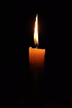**Rose Ceremony**: Stay tuned for the date and details for this annual event at Our Lady of Good Counsel. It will be scheduled around the anniversary of Roe v. Wade decision in January.

**LIFESPAN’s Luminaries:** We have candle kits all set up. This is a beautiful way to memorialize the nearly 59 million babies that have lost their lives due to abortion. Have questions? Call our office!

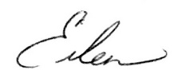 Yours in LIFE,

Eileen Brandt

Director, Wayne County/Downriver Chapter

**Wayne County Chapter**

32540 Schoolcraft Rd., ***Suite 210***

Livonia, MI 48150-4305

email: wcdr@rtl-lifespan.org

734-422-6230 Fax 734-422-8116

***www.miLIFESPAN.org***