***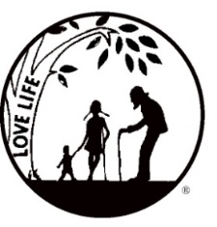****Presenting the Pro-Life Message in Southeastern Michigan Since 1970*

***Right to Life - LIFESPAN***

Life is like an arch. If you discard one segment as worthless,

the span collapses — the value of all life brought low.

*Please post fliers wherever possible and bring it to the attention of your pastor, youth group coordinators and pro-life groups.*

*www.miLIFESPAN.org October 17*, 2017

Hello, Everyone!

Thank you to all who were able to attend the Church Rep Fall Harvest Meeting! You are all amazing! ☺ I think we all came away with some great information—I loved your suggestions! Tons of things happening:

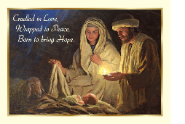

**CHRISTMAS CARDS ARE HERE!** They have arrived!!! Please call and set up an appointment to come and pick up the cards to offer at your church/organization. These religious cards are a great way to let people know that you are thinking of them and sending them Christmas Blessings!

*Please be sure to speak to your pastor and the editor of your church bulletin and*

*ask them to include our November church notes.*

**Entertainment Books ARE IN!!!**

This fundraiser supports LIFESPAN and saves YOU money! We are almost out of the 2017 books that you get free when you purchase the 2018 book for $30. Get yours now! They are available on a first come-first serve basis.

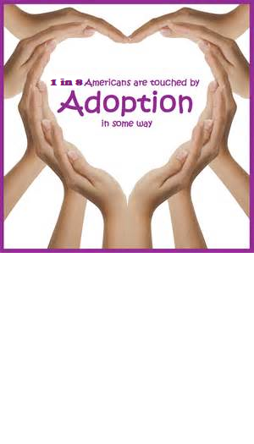***Pro-Life Luncheon LAST CHANCE!!! Register TODAY!!!* Why attend? *SO MANY REASONS***: You are pro-life. You want to know what to tell someone about adoption as the loving option. You want to be better prepared to answer questions about adoption. You are personally interested in adoption for your family. You want to know about the loving option for unplanned pregnancies. Dawn M. Baker, LMSW is the Service Line Director for the Pregnancy Counseling and Infant Adoption programs at Bethany Christian Services and will be our featured speaker.

We will also be getting important legislative updates from Representative Jeff Noble. Pick a reason, or two, and register today! **Saturday, October 21, 2017, 10:30 AM – 1:00 PM O’Kelly Banquet Hall, Dearborn**

**Sign Painting Party** Saturday, November 11, 2017, 12PM. Save the date and plan on joining us for a sign painting party that will help you decorate your home or create a perfect gift for a loved one!



**Lights for Life!** Be sure to help us light our 14 foot tree! Celebrate with us this Christmas Season, remembering those you love. In keeping with the Christmas spirit of giving, caring and sharing, LIFESPAN invites you to help illuminate our “Lights for Life” Tree by donating a light in honor of, or in memory of, someone you love. More details enclosed.



***Movement in Motion*** Bus Trip: Have the youth in your life or your church reserved their spot on LIFESPAN’s Movement in Motion Bus Trip to Washington, D.C. for January’s March for Life? Make sure to do this before all of the spots are taken!

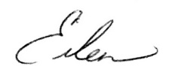 Yours in LIFE,

Eileen Brandt

Director, Wayne County/Downriver Chapter

**Wayne County Chapter**

32540 Schoolcraft Rd., ***Suite 210***

Livonia, MI 48150-4305

email: wcdr@rtl-lifespan.org

734-422-6230 Fax 734-422-8116

***www.miLIFESPAN.org***