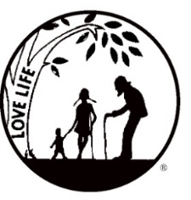
Presenting the Pro-Life Message in Southeastern Michigan Since 1970
Right to Life - LIFESPAN
Life is like an arch. If you discard one segment as worthless,
the span collapses — the value of all life brought low.
Please post fliers wherever possible and bring it to the attention of your pastor, youth group coordinators and pro-life groups.
www.miLIFESPAN.org September 12, 2017
Hello, Everyone!
Thank you to all who supported our Walk for Life! You are all amazing! Tons of things happening:
Please be sure to speak to your pastor and the editor of your church bulletin and
ask them to include our October church notes.

Entertainment Book ARE IN!!!
This fundraiser supports LIFESPAN and saves people money! We have a limited supply of 2017 Entertainment Books available for all who pre-order the 2018 Entertainment Book. They are available on a first come-first serve basis.
Euthanasia/Assisted Suicide: A Panel Discussion at Momentum meeting at Living Word Church in Plymouth. Lunch will be provided. September 28, 2017, 11AM.

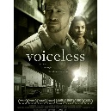
Abolish Abortion Event at Ss. Cyril and Methodius Friday, September 29th, 6:30--9:30 p.m. (doors open at 6:00 p.m.) Location: Ss. Cyril and Methodius Slovak Catholic Church, 41233 Ryan Road, Sterling Heights (near the northwest corner of Ryan and 18 Mile Roads) Registration Deadline: September 26th
LIFE CHAIN October 1, 2017 Make sure to get your registration form into the Main Office so that your location can be listed! Encourage friends and family to stand with you!
Church Rep. Fall Meeting Sunday, October 8, 2017 Mark your calendars and talk to your Pastor/Christian Service Director/Youth Director and anyone else you feel needs to hear more about LIFESPAN, and ask them to attend to the Church Rep. Fall Meeting with you.
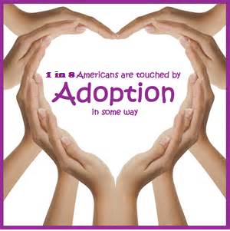
Pro-Life Luncheon Why attend? SO MANY REASONS: You are pro-life. You want to know what to tell someone about adoption as the loving option. You want to be better prepared to answer questions about adoption. You are personally interested in adoption for your family. You want to know about the loving option for unplanned pregnancies. Dawn M. Baker, LMSW is the Service Line Director for the Pregnancy Counseling and Infant Adoption programs at Bethany Christian Services and will be our featured speaker.
We will also be getting important legislative updates from Representative Jeff Noble. Pick a reason, or two, and register today! Saturday, October 21, 2017 10:30 AM – 1:00 PM O’Kelly Banquet Hall, Dearborn
Sign Painting Party Saturday, November 11, 2017. Save the date and plan on joining us for a sign painting party that will help you decorate your home or create a perfect gift for a loved one!
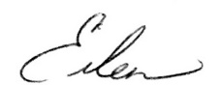
Yours in LIFE,

Eileen Brandt
Director, Wayne County/Downriver Chapter

Wayne County Chapter
32540 Schoolcraft Rd., Suite 210
Livonia, MI 48150-4305
email: wcdr@rtl-lifespan.org
734-422-6230 Fax 734-422-8116

www.miLIFESPAN.org

