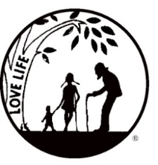
Presenting the Pro-Life Message in Southeastern Michigan Since 1970
Right to Life - LIFESPAN
Life is like an arch. If you discard one segment as worthless,
the span collapses — the value of all life brought low.
www.miLIFESPAN.org August 14, 2017
Please post fliers wherever possible and bring it to the attention of your pastor, youth group coordinators and pro-life groups.
Hello, Everyone!
I hope that everyone is having a wonderful summer, so far! Tons of things happening:
Please be sure to speak to your pastor and the editor of your church bulletin and
ask them to include our September church notes.

Entertainment Book ARE IN!!!
This fundraiser supports LIFESPAN and saves people money! We have a limited supply of 2017 Entertainment Books available for all who pre-order the 2018 Entertainment Book. They are available on a first come-first serve basis.
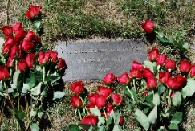
National Day of Remembrance for Aborted Children—September 9th, 1 PM, White Chapel Cemetery in Troy.

We are excited to announce our “Walk for Life” on Sunday, September 10th, 1:30 – 3:00 PM at Sumac Pointe in Hines Park, near Newburgh Road, Livonia. Please encourage everyone to collect pledges and to come out for a beautiful walk that supports a beautiful thing: LIFE! We will be witnesses for LIFE by wearing t-shirts that advertise our cause. More information is enclosed in this mailing!

LIFE CHAIN October 1, 2017 Make sure to get your registration form into the Main
Office so that your location can be listed! Encourage friends and family to stand with you!
Church Rep. Fall Meeting Sunday, October 8, 2017 Mark your calendars and talk to your Pastor/Christian Service Director/Youth Director and anyone else you feel needs to hear more about LIFESPAN, and ask them to attend to the Church Rep. Fall Meeting with you.

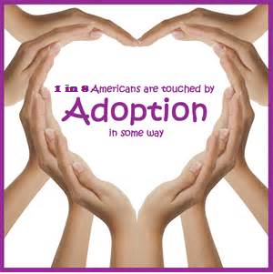
Pro-Life Luncheon Why attend? SO MANY REASONS: You are pro-life. You want to know what to tell someone about adoption as the loving option. You want to be better prepared to answer questions about adoption. You are personally interested in adoption for your family. You want to know about the loving option for unplanned pregnancies. Dawn M. Baker, LMSW is the Service Line Director for the Pregnancy Counseling and Infant Adoption programs at Bethany Christian Services and will be our featured speaker.
We will also be getting important legislative updates from Representative Jeff Noble. Pick a reason, or two, and register today!
Saturday, October 21, 2017 10:30 AM – 1:00 PM O’Kelly Banquet Hall, Dearborn
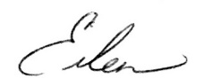
Yours in LIFE,

Eileen Brandt
Director, Wayne County/Downriver Chapter

Wayne County Chapter
32540 Schoolcraft Rd., Suite 210
Livonia, MI 48150-4305
email: wcdr@rtl-lifespan.org
734-422-6230 Fax 734-422-8116

www.miLIFESPAN.org

