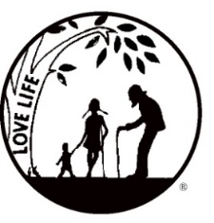
Presenting the Pro-Life Message in Southeastern Michigan Since 1970
Right to Life - LIFESPAN
Life is like an arch. If you discard one segment as worthless,
the span collapses — the value of all life brought low.
www.miLIFESPAN.org June 9, 2017
Please post fliers wherever possible and bring it to the attention of your pastor, youth group coordinators and pro-life groups.
Hello, Everyone!
Well summer has definitely arrived! I hope that you are already enjoying the fun and sun.
PLEASE NOTE: The Wayne County Chapter Office will be closed from July 3-July 17.

Why are we going to be closed? For actual vacation time! Anne Marie is going on a mission trip to Ecuador and I will be on vacation with my family. This doesn’t mean that I won’t be working part of the time, but I can’t be at the office. As always, my cell number is on the office voice mail, so if there is any urgent concern, please feel free to text or call me.

Entertainment Book Pre-Order
This fundraiser supports LIFESPAN and saves people money! We have a limited supply of 2017 Entertainment Books available for all who pre-order the 2018 Entertainment Book. They are available on a first come-first serve basis.
We are excited to announce our “Walk for Life” on Sunday, September 10th in Hines Park, near Newburgh Road. Please encourage everyone to collect pledges and to come out for a beautiful walk that supports a beautiful thing: LIFE! We will be witnesses for LIFE by wearing t-shirts that advertise our cause. We are still getting all of the materials together, so stay tuned for pledge forms and additional information.
Looking for some summer reading? Check out LIFESPAN’s Used Books at
19223 Merriman Rd., Livonia 48152
Our new location is now open in conjunction with Angels, Saints &Stuff – A one of a kind art gallery and consignment décor store that supports area non-profit charities and local artists.
Open during Store Hours: Tue-Fri: 12:00- 5:00 pm & Sat: 11:00 am – 4:00 pm**Enter through Angels, Saints & Stuff on the North side of the Building
- Trips and events are being planned… Tigers’ Game, Casino Trip, Paint and Pour …. STAY TUNED!
Please be sure to speak to your pastor and the editor of your church bulletin and ask them to include our July church notes.

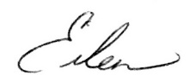
Yours in LIFE,

Eileen Brandt
Director, Wayne County/Downriver Chapter

Wayne County Chapter
32540 Schoolcraft Rd., Suite 210
Livonia, MI 48150-4305
email: wcdr@rtl-lifespan.org
734-422-6230 Fax 734-422-8116

www.miLIFESPAN.org

