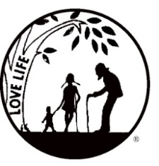
Presenting the Pro-Life Message in Southeastern Michigan Since 1970
Right to Life - LIFESPAN
Life is like an arch. If you discard one segment as worthless,
the span collapses — the value of all life brought low.
Please post fliers wherever possible and bring it to the attention of your pastor, youth group coordinators
and pro-life groups.
www.miLIFESPAN.org May 23, 2017
Hello, Everyone!

Wow! What a busy month! So sorry for the lateness of the Church Notes this month; Annual Dinner, Silent Auction, Mother’s Day, Garage Sale….just thinking about it makes me exhausted! LOL
Thank you to all who helped at the Annual Dinner; what an amazing night!
Thank you to all who donated and assisted at our chapter’s garage sale—you are really appreciated! The garage sale was a success and we couldn’t have done it without YOU!

Mother’s Day
Thank you to everyone who made a special effort to gather donations for the live carnations. We have made the decision to not do live carnations for Mother’s Day again. We feel that it puts way too much work on the Church Reps. Instead, we have already found a vendor for chocolate rose lollipops for next year. We think that this will be easier on everyone and get some chocolate to the amazing moms out there! We hope that this allows you all to give a great sigh of relief! We will still offer the assortment of other products for donation, too.

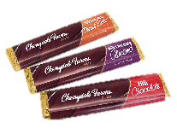
Father’s Day
Pens with a stylus tip (“Thanks, Dad, for Life! Happy Father’s Day”), chocolate bars, tape measures, and stands for phones/tablets will all be available for donations. The candy bars will all be labelled with the phrase “Life is Sweet, Thanks for LIFE!” and one of these facts about human development with a cute baby picture:

- A baby’s eye color is predetermined at conception but most are born with blue or grey eyes. Around his/her 1st birthday, the eye color will have changed to its permanent color.
- Babies recognize their mother’s voice and native language because of what they hear in the womb.
- Fingerprints develop 6 weeks after being conceived. The fingerprint pattern will never change.
- Most babies can smile just 11 weeks after conception.
- We’re all human from day one!

- Trips and events are being planned… Tigers’ Game, Casino Trip, Paint and Pour …. STAY TUNED!
Please be sure to speak to your pastor and the editor of your church bulletin and ask them to include our June church notes.

Yours in LIFE,

Eileen Brandt
Director, Wayne County/Downriver Chapter

Wayne County Chapter
32540 Schoolcraft Rd., Suite 210
Livonia, MI 48150-4305
email: wcdr@rtl-lifespan.org
734-422-6230 Fax 734-422-8116

www.miLIFESPAN.org

