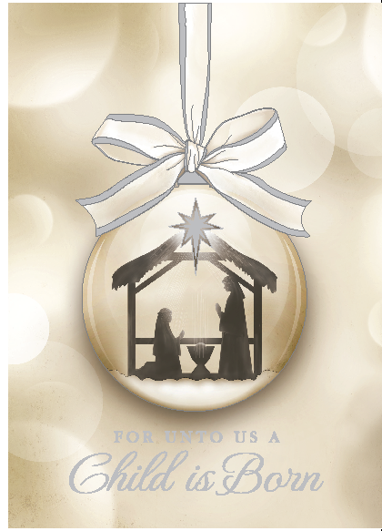
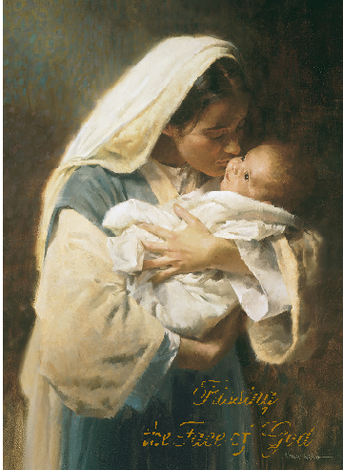
2015 LIFESPAN Christmas Cards
Your purchase of LIFESPAN Christmas Cards represents support for the pro-life activities, education and
materials offered during the coming year.
To place an order, arrange for pickup at a location near you and/or for more information, call one of our chapter locations:
Oakland/Macomb County: 248.816.1546 or Wayne County: 734.422.6230
Additional cards from previous years (at a discounted rate) will also be available on a limited basis.
Contact our offices for more information!
For Unto Us A Child is Born
This beautiful card depicts the Holy Family in subtle cream and ivory tones with embossed and silver foil detail. A silver box and silver foil lined envelope complete this elegant Christmas greeting.
Inside Verse:

May you have
the joy of Life
the blessing of hope
and the peace of His love
During this holy season and always

Wishing you a
Merry Christmas

Actual size: 5.63” x 7.88”
$17 per box of 20
Kissing the Face of God
This captivating card brings us the famous “Kissing the Face of God” image by Morgan Weistling. The image is in real-life colors and has Mary in her blue and ivory dress holding the Infant Jesus.
There is a white envelope to carry your message to loved ones.

Inside Verse:

As we reflect on the beautiful Face
Of the newborn Savior
May we look on all Life
As a beautiful reflection of God’s promise

May you have a Blessed Christmas

Actual size: 4.84” x 6.75”
$7 per pkg. of 10

Both cards are made in the U.S.A.

